Down For Maintenance
Down For Good:
A good end to a long night
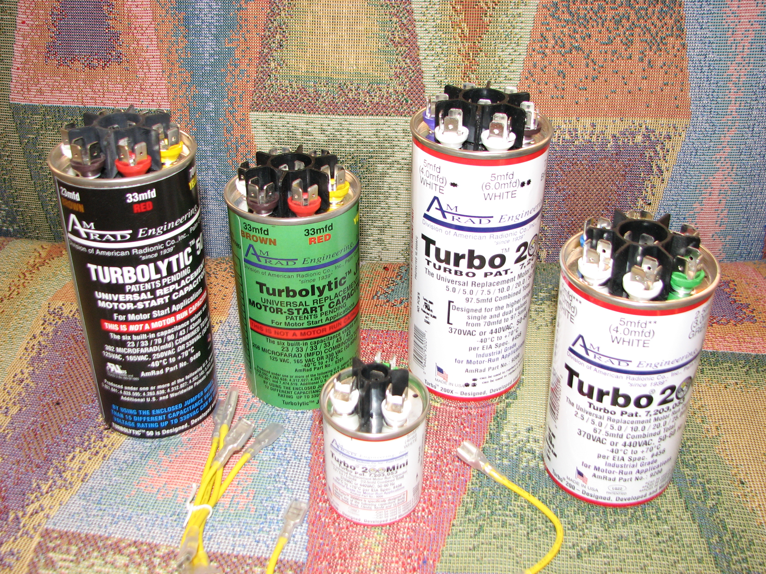
By Gary Minker of Radio Works R.F. Consulting
www.RadioWorksR.F.Copnsulting.com
Gary@RadioWorksRFConsulting.com
561.969-9245

There you are, working at the transmitter site on your one and only transmitter trying to figure out why the thing quit and where did that wonderful smell of Bakelite come from. Testing, testing, groping for parts, working through the night you go. It almost sounds like a Christmas Carol but you are sure it is not. The hours run on and progress is slow but on again, on again, slowly you go. There’s that Carol again. So dawn approaches and you are pretty sure that you have found all of the problems and after hours of “pushing the button”, you are certain that this push of the run command will be your last and you can finally go home to the comfort of your slippers and chewed up newspaper.

Ready, set, go, after hours and hours of pushing that nifty little green button much to fast and to many times, you keep hoping to make your troubles go away and suddenly you notice that the transmitter wants to come up and run and lo, the earth stands quiet and the meters all come up but only for that week long instant of 4 to 6 seconds and Clunk, you are down again.

Now What! I fixed the blown fuses on the IPA, I checked my automatic power control, I poked and fixed and checked and it ran so Now What?? It ran, I saw it,,, didn’t I? Ohh Maaann,,, Now what. So back in to the box you go searching for the latest show stopper. Ah you say, as you find another fuse out. You easily replace the fuse and around you go, keeping one hand in your pocket holding on tight and you press the little green button. Run baby run as you hum a Cheryl Crow song and 3, 4, 5, 6, the meters are up, the music is playing from the speakers and not from your mind and Clunk. After a few minutes of searching, you come up with the same fuse so now after a few deep breaths you realize the fuse belongs to the blower and you just happened to NOT hear the thing spool up and you DID hear this nasty humming right as the fuse blew.

After twice running the inventory of parts you have on hand for all of 4 seconds you realize that you do not have a new motor and you certainly do not have a new run or start capacitor. You rip in to the blower and find that the start cap is open and there is thankfully no run cap needed and you frantically start thinking what you can tear apart to steal a capacitor from, any capacitor, just anything that might handle 240 Volts for 30 seconds and might accidentally have about 12 uF for a value and you know deep in your stomach that you have nothing and it’s Saturday in outer Mongolia and you are toast. But wait, your next door neighbor is a service technician, there is only 19 inches of snow on the ground, and he works for an appliance company and he might have just the thing you need. You sheepishly call and wake him and ask that all embarrassing question,,, Do you have any capacitors? To your great joy he brings you the Holy Grail of Capacitors. He bestows upon you an AmRad Engineering Turbo 200 Run Capacitor. This is just the thing you were looking for. This handy little cap is actually 5 capacitors in one and can be ganged up in parallel to create 200 combinations of capacitor designed to allow you to keep your job. With the set of these that is called the “truck pack”, you can substitute virtually any start or run capacitor for 120VAC to 440VAC and get back to you slippers. No more trying to stock a dozen or more spare oil filled Electrolytic’s for your Air Conditioners, UPS’s and Blowers. While you can never have enough spare parts, you should always have the right parts to deal with these sudden surprises.

