
DON’T DO THAT:
PIPE CUTTER BLUES
By: Gary A. Minker

If you are in the Broadcast Engineering business as an employee or contracting member of the Gainfully Self Unemployed, you are probably over the age of majority and are not too crazy about folks shaking their finger at you bellowing, Don’t Do That!!

Get over it. It is these well meaning folks that are either trying to save you from killing yourself, your apprentice, or the station cat, and in this well meaning insubordination, you ought to listen to what they have to say and not just write it off as their childish folly. Those older, and some younger, may have been to the goat roping that you missed and in this series of articles, I will be that thorn in your side and welcome your thoughts by Email or voice toward the same content.

This first offering in the series is called Pipe Cutter Blues:
Go on, admit it, you have either taken the easy way out on your last Rigid Line EIA install or you have succumbed to the joke that convinced you that the use of a pipe cutter is okeedookee on rigid Line. See, I did get your goat didn’t I? The part I find hilarious is that the members of the pipe cutter guild staunchly defend their position and every time I see it done, I think of the Wizard Of Oz’s Lollypop Guild.

There is a frightening number of pocket protector rated “plumbers” out there that have gone the way of the pipe cutter and in this are guaranteeing that the work that they did will come back to haunt someone and it won’t be Halloween. There is not a one of you out there that has a clue where this is going but as you will soon see, and if you have read my works before, you know there is a punch line coming after some extremely convincing data.

Fallacy number 1:
This works just fine.
Sure it will if you never run over 1,000 Watts at a V.S.W.R. of greater than 1:1.4 for 7/8” and perhaps 10,000 Watts on 6”. Go ahead and say it out loud so you can convince yourself and everyone around you. Repeat after me… This guy who wrote this is an idiot!

Fallacy number 2:
I de-burr the line and file the ridge ring off and there is nothing wrong with these joints.
Sure it is, if you file the living daylights out of the inner, scratch it up so it looks like the surface of Mars, and gouge the inner surfaces so badly you groove them because the de-burring tool that you love will not do the trick.

Radio Works R.F. Consulting 7225 Catalina Isle Drive Lake Worth, Florida 33467
Office ( 561 ) 969-9245 Email Gary@Radioworksrfconsulting.com
The information contained in this communication is considered to be Work Product and has an imputed value.
Reproduction or dissemination of this information is prohibited without compensation to the author
Fallacy number 3:
Copper is springy and the bullet fingers will conform to a few minor abnormalities.
See fallacy number 1.

Ok, now the facts. The table in Figure 1 is an spread sheet of the data that I accumulated just for your dart throwing pleasure. You will see that there is a comparison for a number of differing cutting and finishing techniques. The Pipe Cutter genre’ is listed first and you will see that I showed no favorites and used the two common types of cutters and took the typical length of time, and the ridiculous length of time to cut the test pipes. Most folks do not even know that there are two kinds of cutter wheels. Damn pipe is expensive but this was worth it.

The two pipe cutters are commonly known as Steel Wheels and PVC Wheels. The Steel Wheels are broader, and have a wider tip chamfer. This is to impart strength to those heavy handed galvanized steel pipe cutting Electricians and you well intentioned Engineering types. The PVC Wheels have a very narrow shoulder and are quite sharp as wheels go. They also have a deeper edge to shoulder distance along with the low bevel angle to allow cutting the thicker walls of the plastic pipes.

Just like your mother always told you to use a metal file on metal and a wood file on everything else including your horses hooves, you should use the wood file on copper to help square the ends if you mess up badly or you don’t have a nice belt dresser set up. In a choice of evils, the PVC wheel is the optimum wheel for cutting copper pipe. Damn, did I really say that? I am just kidding, but if you were so disposed to do this foolish thing, have a look at the table of data and see what you are in for.

The table in Figure 1 and the drawing in Figure 2 clearly show the propensity to cause a ridged ring just inside the outer lip of the pipe that your file will miss quite a bit of, and the de-burring tool will fall short of. The action of the cutter wheel also raises a lip on the outer surface of the pipe but that is more readily removed as an arcing point for inner conductors than the damage to the inner surface. I admit that if you stand there and rotate the cutter tool 100 times like using a lathe and tool like I did, and apply the slightest changes in wheel pressure that you might actually get a decent cut, but the usual “accidental” number of turns is around 20. I have watched so many people do this that I have nightmares about it and 20 is the number. In comparing the data from the Steel to PVC set up, you can see that the ridge ring damage is progressively deep with the type of tool and with the number of turns taken.

OUR SAVIOR:
Enter the band saw,,, This device is the savior of the day. While I know that some of you use a 90 tooth carbide miter chop saw, (with ear plugs I hope) this is better than the mighty pipe cutter but is not the optimum method for field cutting copper pipe. The carbide chop is the lazy way out of this debacle and is not even recommended for 8” and up. The two typical band saw blade tooth counts are 24 and something else between 12 and 18 Teeth Per Inch (TPI). There is a huge difference in the tearing of thin wall tubing when you are cutting copper that is only .040 thick. 1/16th of an inch is .0625 inches. 1/24th of an inch is around .041 inches. Does that number seem familiar?

Cut Method |  |  |  | change to | net change | Dia. Shrink
Pipe Cutter Data | PVC Wheel |  | Outer Dia. | 1.31 | -0.001 | -0.002 |  | avg of 5 | 100 turns
 | PVC Wheel |  | Outer Change | 1.3
 | PVC Wheel |  | Inner Change |  |  | -0.001 |  |  | De Burred
 | PVC Wheel |  | Outer Dia. | 1.31 | -0.006 | -0.012 |  | avg of 5 | 20 turns
 | PVC Wheel |  | Outer Change | 1.298
 | PVC Wheel |  | Inner Change |  |  | -0.005 |  |  | De Burred
 | Steel Wheel |  | Outer Dia. | 1.31 | -0.011 | -0.022 |  | avg of 5 | 100 turns
 | Steel Wheel |  | Outer Change | 1.288
 | Steel Wheel |  | Inner Change |  |  | -0.011 |  |  | De Burred
 | Steel Wheel |  | Outer Dia. | 1.31 | -0.022 | -0.043 |  | avg of 5 | 20 turns
 | Steel Wheel |  | Outer Change | 1.267
 | Steel Wheel |  | Inner Change |  |  | -0.022 |  |  | De Burred
Band Saw Data | band saw |  | Outer Dia. | 1.31 | -0.0005 | -0.001 |  | avg of 5 | used blade
 | 24tpi |  | Outer Change | 1.3
 |  |  | Inner Change |  |  | 0 |  |  | De Burred
 | band saw |  | Outer Dia. | 1.31 | -0.0009 | -0.0018 |  | avg of 5 | used blade
 | 16tpi |  | Outer Change | 1.292
 |  |  | Inner Change |  |  | -0.001 |  |  | De Burred
Mitre Saw Data | Miter saw |  | Outer Dia. | 1.31 | -0.0044 | -0.0088 |  | avg of 5 | used blade
 |  |  | Outer Change | 1.3012
 |  |  | Inner Change |  |  | -0.002 |  |  | De Burred
Misc Information | Best horizontal dia deform .097 long
 | Worst horizontal dia deform ..35 long
 | Length of de-burr bevel .047 |  |  |  |  |  |  | avg of 5
Pipe Cutter Data |  | total roundness variation from pipe cutter - + .006
 |  | Shrinkage dia | Best | Dia -0.002
 |  |  | Worst | Dia -0.037
Bullet Data | O.D. | Bullet Dia. | 1.241 |  | 0.006
 |  | Max Dia | 1.247 |  | 0.006
Pipe Data | O.D. | pipe | 1.31 |  | Nominal
 | I.D | pipe | 1.23 |  | Nominal
 | Wall thickness |  | 0.04 |  | Nominal
FIGURE 1

You want a very fine tooth count so that the teeth are smaller than the object that you are cutting. Even with the tabular data displaying the effects at both 24 and 18 TPI as well as the ¼: spacing of the 90 toothed carbide wonder, you can see that there is just no explainable comparison that will convince anyone that the Pipe Cutter is the way to go.

Just in case mountains of tabular data are not your thing, let’s have a look at Figure 2. This is an average and accurate dramatization of certainly not the worst case pipe cutting episode. You can see in the top drawing that the cutter causes a gradual taper of the tubing that recedes backward on to the tubing shaft quite far. This is both from the compression of the centering wheels, and the cutter wheel(s). Some cutters have more than 1 wheel. This is called shrinkage. The Pipe Cutter actually shrinks the copper by .002” on the receding body, up to .6” back from the front edge, and at the point of cut, you can see that the taper increases exponentially, very much like the curve of an ellipse and then leaves you with a sharp rise that is a real finger stripper. I know, you are thinking that your trusty round (bad file) or half round (metal or wood,, bad file) will knock that sharp edge down and tame that taper. Guess again superman. By the time you file away on this poor piece of pipe, you will have ruined the mating surfaces of the inner and the bullet, and cause zillions if gouges, grooves, and ridges that will burn indelibly in to the bullet and super heat those arcing points. Then after a few hundred thermal cycles, the end of life is nearer than you might think.
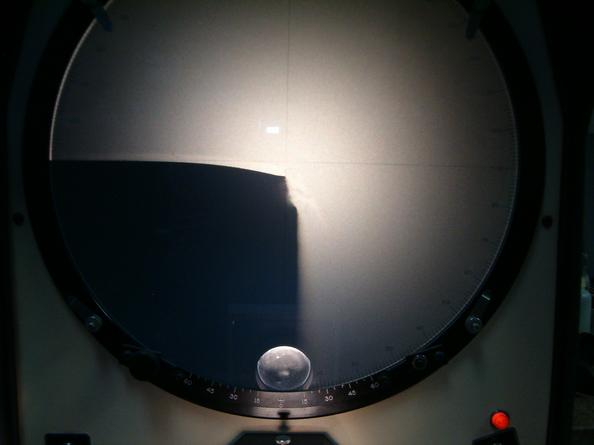
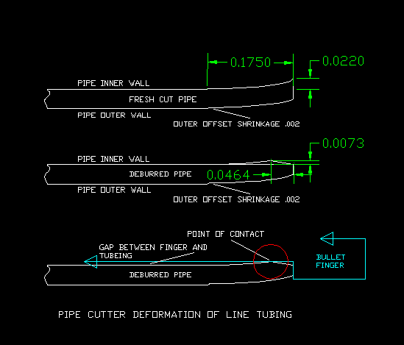

FIGURE 3

FIGURE 2

In Figure 2 at the bottom, you can see the teensy little ridge ring (circled in red) that your file missed. According to Murphy, these forgotten filed down lumps leave a zit in the tube at least once on every bullet finger and is WORSE than if you filed it at all. If you left it alone, you would at least have a continuous ring to make a few microns of contact between the surfaces instead of those couple of teeny tiny points your file left behind. After all, this theory works for watch band springs and their round wire microns of contact, right? Figure 3 is a photo from an optical alignment comparator to show the expanded view of the damage to the outer diameter.

Man (or woman) up and do the right thing. Your choices are clear. The guided hand held hack saw, the hand held portable band saw, the mounted chop type band saw, or for those industrial size installations, the floor mounted rolling head slicer, are the tools of choice.

Yes, I did mention that there are those of you who use the 90 toothed carbide wonder, and the numbers from it are not too bad but you just can not beat the thin blade.

I should mention that having the right files, de-burring tool, and belt dresser power tools for squaring and cleaning the pipe ends just prior to the final de-burring, Scotch-brighting and final chemical cleaning, are also very important, but those may be topics for another day. Make sure your fingers never leave your body.

The photos in this article are embedded at full resolution.



