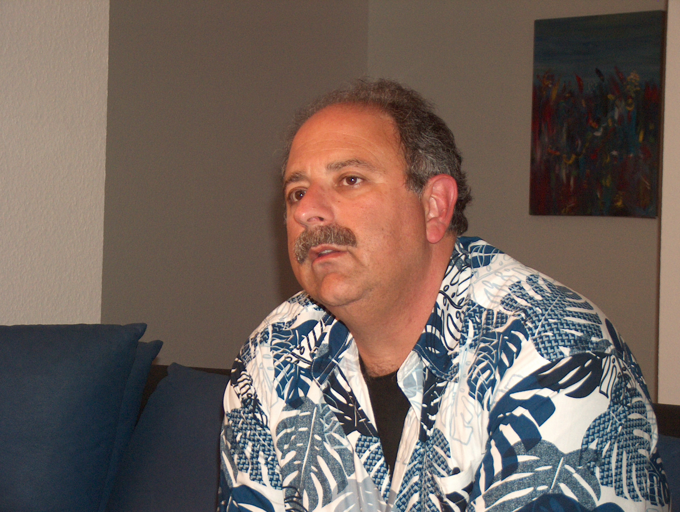
DON’T DO THAT:
Cell Extender Crisis
By: Gary A. Minker

If you are in the Broadcast Engineering business as an employee or contracting member of the Gainfully Self Unemployed, you are probably over the age of majority and are not too crazy about folks shaking their finger at you bellowing, Don’t Do That!!

Get over it. It is these well meaning folks that are either trying to save you from killing yourself, your apprentice, or the station cat, and in this well meaning insubordination, you ought to listen to what they have to say and not just write it off as their childish folly. Those older, and some younger, may have been to the goat roping that you missed and in this series of articles, I will be that thorn in your side and welcome your thoughts by Email or voice toward the same content.

With the ready supply of Cell Phone Extenders, and the nearly total lack of understanding as to what makes them work, people need to realize that these nasty little boxes cause more system degradation, interference, and outright mayhem than they are capable of being helpful. While an amplifier is an amplifier and some are filtered, some have “Protection” circuits and others brew a really awful cup of coffee, the bottom line to these noise generators is that over ninety percent of them are installed incorrectly.

Leaky Hose
The first mistake is that they are sold with cheap braided cable as a part of the connect kit. I don’t care who makes it, what the percentage of shielding is or how many layers of braid and foil it has, braided cables are nothing more than a leaky garden hose that should be relegated to exactly that duty. Let’s get real here, the goal is to amplify an already weak signal and boost it to a usable level in a questionable environment. Anyone with a half an ounce of sense that has ever used a spectrum analyzer knows that a braided test cable with quality connectors and a load on the end will pick up anything of barking level. This problem is not just intrusion but extrusion. Errant signals squeeze in to the cable and squeeze out of the cable and this messy leakage can cause feedback in your new magic box. The moral of this paragraph is, Use Quality Cable, even if it is braided.

Poor Choices:
The next problem with these megaphones of fuzz is the incorrect selection of antennae. These devices are NOT supposed to be broad banded so that you can use them for every carrier from here to Pluto. They are supposed to be carrier specific to help minimize their inherent ability to create noise. The antennas that are supplied with these cute little boxes are often low and moderate gain.

Radio Works R.F. Consulting 7225 Catalina Isle Drive Lake Worth, Florida 33467
Office ( 561 ) 969-9245 Email Gary@Radioworksrfconsulting.com
The information contained in this communication is considered to be Work Product and has an imputed value.
Reproduction or dissemination of this information is prohibited without compensation to the author
The Donor antenna is usually an omni and receives numerous donor sites of carrier which only serves to corrupt the selective process of the handset. Quality systems will have a directional antenna so that you can Target the one site that serves you the best. The inside repeater antenna is often a low gain omni that blurts out what the other antler sees and pollutes the environment that it is introduced to. If these are not bad enough problems in themselves, the antennae are usually also installed incorrectly.

The Really Big Issue:
The incorrect installation of these antennae is the major player in these devices destroying a half mile radius of operation for the general community. If you look at the drawing below, you can see that the moderate gain omni antenna of the donor antler looks in to the radiated pattern of the host antler and then the noise floor growth and feedback carrier spurs begin. It is bad enough that all the so called safety circuits that are so prudently and proprietarily protected by Patent and force, really do not perform as suggested in many cases, and the errant antler selection and installation only exacerbates these problems.

If you really believe that an extender system will do the trick for your situation and you don’t want to go the route of the professional Bi-Directional Amplifier (BDA) design and installation, for the sake of Pete, buy a system with the right components and be sure that they are installed correctly. With the 15 to 30 dB of gain that these products offer, antenna isolation is crucial to the proper and noise free operation of these systems. Mount the host and donor antlers in a vertical orientation and/or use directional radiators. Use the “Heliax” of your choice and select the correct host cell.

Your Neighbors will thank you and the local carrier will not have to serve you with a cease and desist order.

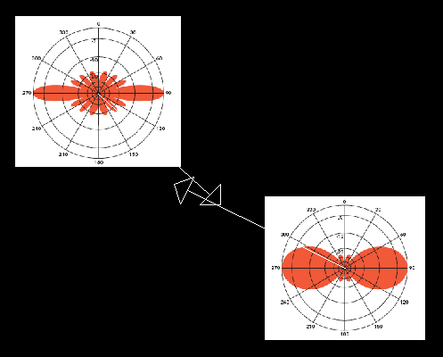

FIGURE 1: Offset antennae interfere with each other when not vertically oriented,
even if they are different gain levels

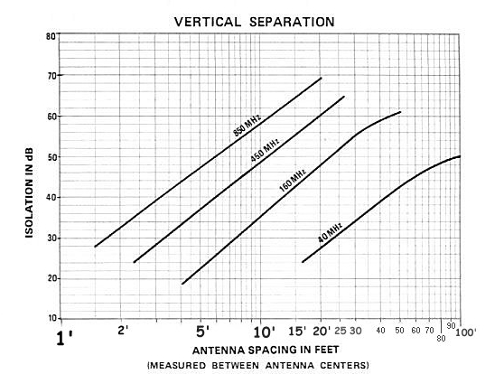

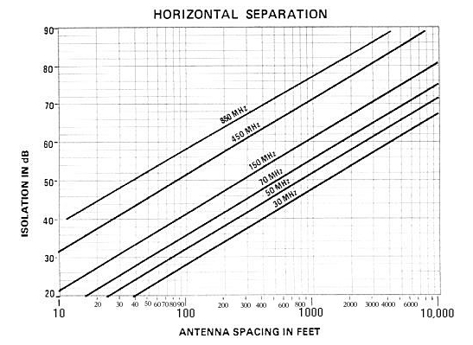

The graph tables used are from Mike Morris, published on DXZone.com

