
DON’T DO THAT:
Air Filters, or so they say
By: Gary A. Minker

If you are in the Broadcast Engineering business as an employee or contracting member of the Gainfully Self Unemployed, you are probably over the age of majority and are not too crazy about folks shaking their finger at you bellowing, Don’t Do That!!

Get over it. It is these well meaning folks that are either trying to save you from killing yourself, your apprentice, or the station cat, and in this well meaning insubordination, you ought to listen to what they have to say and not just write it off as their childish folly. Those older, and some younger, may have been to the goat roping that you missed and in this series of articles, I will be that thorn in your side and welcome your thoughts by Email or voice toward the same content.

The Air Filter is such a seemingly innocuous device that should be so simple to select and install but as you might get to think about them, the choices are many, their names are assorted, and the functions are totally misleading. Some of them are great, and some scream Don’t Do That!

How can an air filter be so deceptive? Let us go over some of the range of what I have run in to in my limited span of knowledge. We have, Hog Hair, Automotive Cartridges, Glass Floss, Foam, Cloth, Hospital Clean Room Sticky Media, Pleated Felt, Grease Traps (also known as The Bug Catcher) and the Mac daddy, Electrostatic in active and passive.

With just these nine predominant types of air filters in mis-use today, we should understand the pitfalls of them and why you Should Not Do That.

Hog Hair;
This cheap to buy and worse to use filter is commonly blue in color, sold in rolls and trimmed with a garden hedge clipper in to the shape desired. It has very low insertion loss, good bug rejection and terrible dust stopping ability. Some of these brands even insinuate that they are washable and re-usable, but not ecological. Gee, this is just what I want to introduce fractionalized fiberglass in to the sensitive areas of my RF cavity.

Automotive Cartridges:
These amazingly good filters have been seen on TV transmitters as well as other critical usage systems where velocity and cubic volume take a back seat to quality of filtration. After all if a cartridge type unit is good on your Masseratti, it should work great on your IOT. These are an inexpensive and good choice for the right application.

Radio Works R.F. Consulting 7225 Catalina Isle Drive Lake Worth, Florida 33467
Office ( 561 ) 969-9245 Email Gary@Radioworksrfconsulting.com
The information contained in this communication is considered to be Work Product and has an imputed value.
Reproduction or dissemination of this information is prohibited without compensation to the author
Foam / Cloth:
This is a catch all grouping that covers felts, cottons, and a number of woven or molded foam based media that are often sold on a roll, cut to shape by scissors and might claim to be re-usable and washable. There’s that green thing again. The main objection here is that the flimsy nature of the media is really a supplement to another type of more rigid structure and when used as a stand alone filter, often gets shredded by the fan or blower wheel, and distributed imprudently throughout the critical areas of the transmitter or power supply. This makes for a dandy fire hazard and could cause you to do some fancy explaining to the boss. In the presence of corona and high Voltage ( I wonder where that comes from) these products tend to disintegrate so don’t use these either.

Spun Fiberglass:
This outstanding carryover from your home furnace is a low price sort of effective filter for bugguts, and other large format intrusions but even though it seems to filter better as it clogs up, it leaks mercilessly and when this happens, and as corona is our friend, the dust mites that leak around the sides and through the fibers, make a nasty mess when the filter suffers an implosion from the vacuum of the blower wheel.

Hospital Clean Room Sticky Media;
This fibrous material is used very often in the critical ventilation and filtration systems in hospital surgical wards. This fibered felt has one sticky side that attracts small particles and bug-guts (bugguts) and keeps them from eating away at your insides. This media is often applied as a supplement to another mode of filtration as an additional step. HCRSM is usually changed out at a ratio of 4:1 over the conventional media because it clogs up fast, and does a very nice job. Just don’t forget to install it with the sticky side up stream, not on the leeward side of your air flow, though we can argue about that later.

Pleated Filters;
This is the most popular filter medium today. They are available in many thicknesses from ½” to 3” in total depth, and between the type of felted material and the sheer surface area, is an incredibly efficient and long lasting filter. (see automotive) Some are available with a sticky side which emulates the HCRSM mentioned above. These filters can run for quite a long time before needing changing and catch an amazing amount of small dirt and dust depending on the manufacturer since as you can imagine, all media are not created equally.

The Metallic Woven Grease Trap;
This hideous farce of an air filter was stolen directly from some mega-kitchen vent hood and consists of the visual representation of flat ribbon chain mail armour. This joke of a filter was actually supplied by a large number of transmitter companies as an RF systems air filter for many years and its main claim to fame is that it is termite proof. After all, nothing eats steel mesh,, right? These grease traps as they are called at restaurants have low lizard catching ability, less bug catching ability and near zero dust and dirt holding power unless the dirt is already laden with a sooty greasy compound as a result of the fire that already occurred from the lack of filtration. I do have to admit that they make a great R.F. Shield as evidenced by the bright red glow emanating from the energized portions of the mesh.
The king of the creek,
Electrostatic:
Electrostatic filters have made such progress over the last 20 years to grow from the conventional two plates with a large lethal Voltage differential charge, to various self excited plastics and fibers that static up just from the high speed rush of the passing air. No matter which form of electrostatic you might pick to use, these filters make great lizard stoppers, super bug zappers, and immaculate dust collectors. Like any small child or animal, they require a periodic bath and un-like conventional filters, these are re-newable, eco-green, washable and will keep your high Voltage where it belongs in the cavity and power supplies, and not let it leak to places you would rather it not go.

Don’t let the cheapness of a few cents deter you from doing the right thing here. Air filtration is key to long life and enhanced up time. If you don’t believe me, ask an asthmatic.

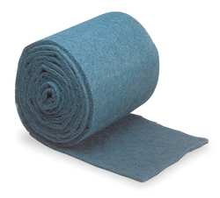
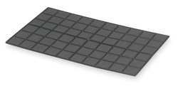

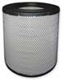

Hog Hair Filter Cartridge Filter Foam / Cloth Filter

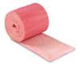
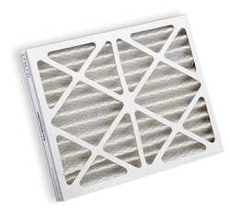
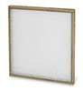

Spun Fiberglass Filter Sticky Back Fiber Filter Pleated Filter

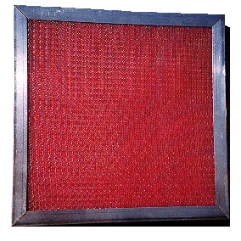
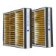
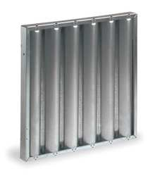

Grease Trap Woven Metal Passive Electrostatic Active Electrostatic

There are even creative ways to incorporate additional filtering methods to your transmitter or device. Let your imagination run wild and if you are highly successful, you will find that you clean your box less often and might get an offer from some imaginative engineering company.
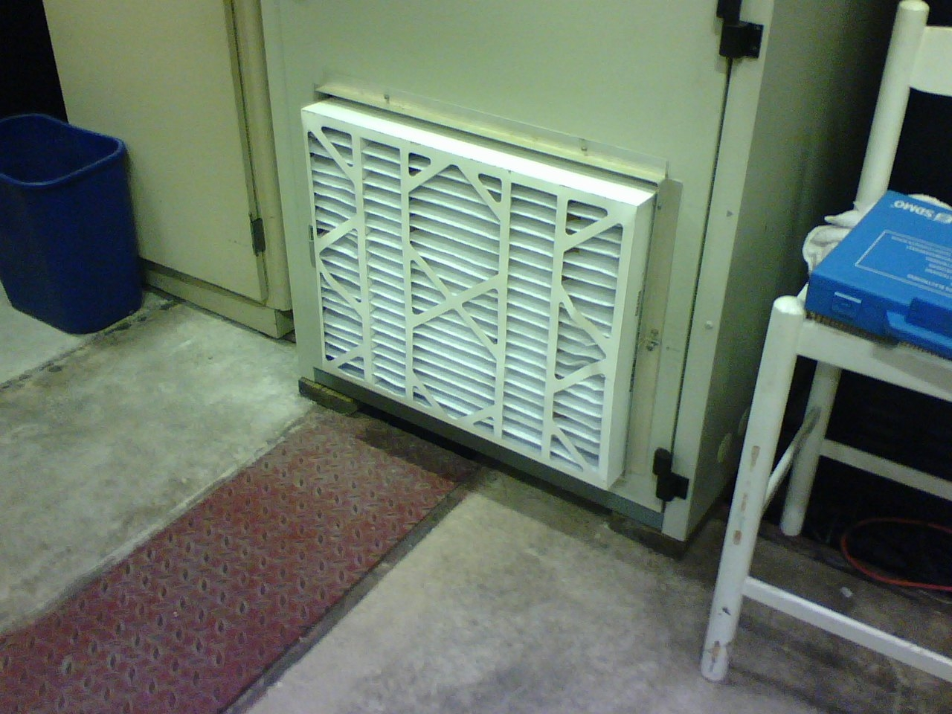

Happy Vacuuming ☺ 

